833M Monoblock Amplifier Manual.

Congratulations on your purchase of the AM Music 833m, Pure Class A, Single Ended Monoblocks. You are now the owner of one of the World’s finest amplification systems. This amplifier is the culmination of 14 years of careful research and development, in the search of the mythically perfect amplifier. We believed that we have achieved this with this amplifier.
Unpacking and assembly:
Carefully remover the amplifier components from their cartons. The modules are very heavy and care should be taken to not damage the amplifier or cause yourself injury in lifting them. Having two people available is advisable.
Carefully unpack the 833 tube. The tube mount has two thumbscrews to securely hold the tube in place. This is accessed by unscrewing the 4 chrome knobs on each corner of the tube surround.
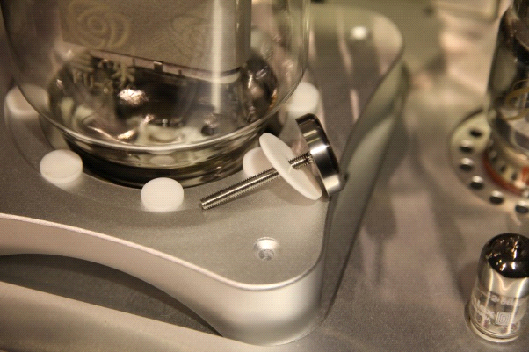
Remove the 4 screws (as shown) and carefully lift the surround by about 8cm to allow easy access.
(As shown below)

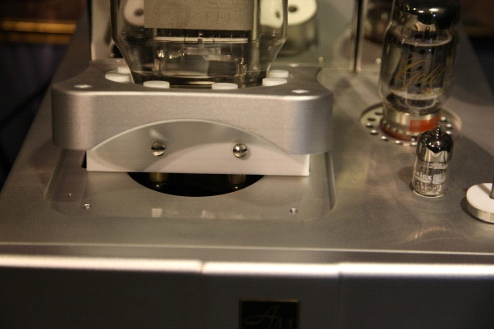
Insert the 833 tube, making sure that it is in as far as it will go, and firmly tighten the two thumbscrews. Replace the assembly and refit the 4 screws, tightening them until they are firm, but do not over tighten.

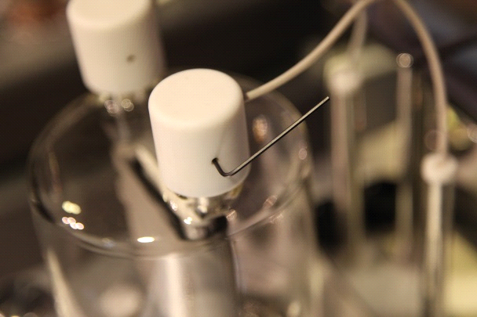
Fit the two Teflon caps to the electrodes on top of the tube. Using an Allan key, tighten the grub screw as shown to ensure that the cap is secured to the top of the tube. (See following warning on next page)
WARNING. The AM Music 833M does not run at the excessively high voltages of some other Super Amps, but there is 900V present at the top caps, when the amplifier is switched on. This voltage can be extremely dangerous, and if the cap is removed when in operation, a severe electric shock is possible. It is therefore very important that the caps are secured by doing up the grub screw to prevent any inexperienced person removing the cap. If properly secured, it is completely safe. The voltage drops to zero as soon as the power is switched off and the green operating light is off. Ensure that the power is off and the power lead is removed before attempting to remove or access the tube.

On/off switch:
The on/off switch of each amplifier is on front centre of each amplifier.
Driver Tubes:
Fit the ECC88 and KT88 Driver Tubes. Be sure to ensure that the pin orientation is correct and do not force them. The KT88 has a keyway on the base and will only fit one way. Line the key on the tube with the slot in the tube socket. Do not rock the tube excessively in the socket to fit or remove it, as the guide is Bakelite and is easily broken off. This will not affect the operation of the tube, but it makes fitting difficult, and if the tube is fitted incorrectly, amplifier damage will occur.
Connect the amplifier to your Hi Fi System. If in doubt as to whether to use the 4 or 8 ohm taps on the amplifier, start with the 8 ohm. Just because a speaker is rated at 4, 6 or 8 ohms does not necessarily mean that is the load seen by the amplifier when playing music. When the amplifier has been biased and is warm, listen to some music and then connect to the 4 ohm taps and listen to the same piece again. The one that sounds fuller, stronger and more musical is the correct setting. Having it on the incorrect taps will not damage the speakers or the amplifier. Contrary to most amplifiers, the 833M more often sounds the best on the 4 ohm taps.
Biasing: The biasing on the amplifier was reduced prior to shipping as a safety measure. Once the amplifier has been on for a while and is fairly warm, connect a Multimeter to the red and black biasing terminals on the centre of the amplifier. (As seen from the front).
Set the Meter on DC Volts, and adjust the screw between the two plugs until it reads 2.2V.
Repeat on the other amplifier.
After about a month or more of running, or about 200 hours, check and reset the bias. After this, there is no real need to keep checking it, unless the tube is replaced, as the bias will naturally drift as the tube ages.

These amplifiers give off quite a lot of heat, so please ensure that each one has adequate ventilation

Warranty:
The warranty on all AM products is two years parts and labor. The amplifier must be returned to the factory, or to the dealer from which it was purchased, or to a repairer authorized by the factory or the dealer. The warranty on tubes is 3 months from purchase. If a tube lasts 3 months, then it is most likely to last the normal life cycle.
Please contact your dealer if you have any other questions or if you would like any information on other AM products.
AM wishes you many years of very happy listening. Thank you.

Data specifications:
Power Tube 833
Tube complement | ECC88 or KT120,KT150 as the drivers, KT88 as the amplifiers . 833
Frequency response | 20Hz-100KHz
Input Impedance | 100k ohms
Input sensitivity | 1.0Vrms
S / N | > 95dB
Input selections | RCA single-ended ; balanced / XLR
Power Output | 120w/ch
Load impedance | 4 & 8 ohms
Power consumption | 400W(each)
Power supply | 100,110,120,220,230,240 VAC 50-60Hz
Dimensions (W * D * H) | 400 X 500 X 284 (mm)
Weight | amplifier 50 Kg X 2

